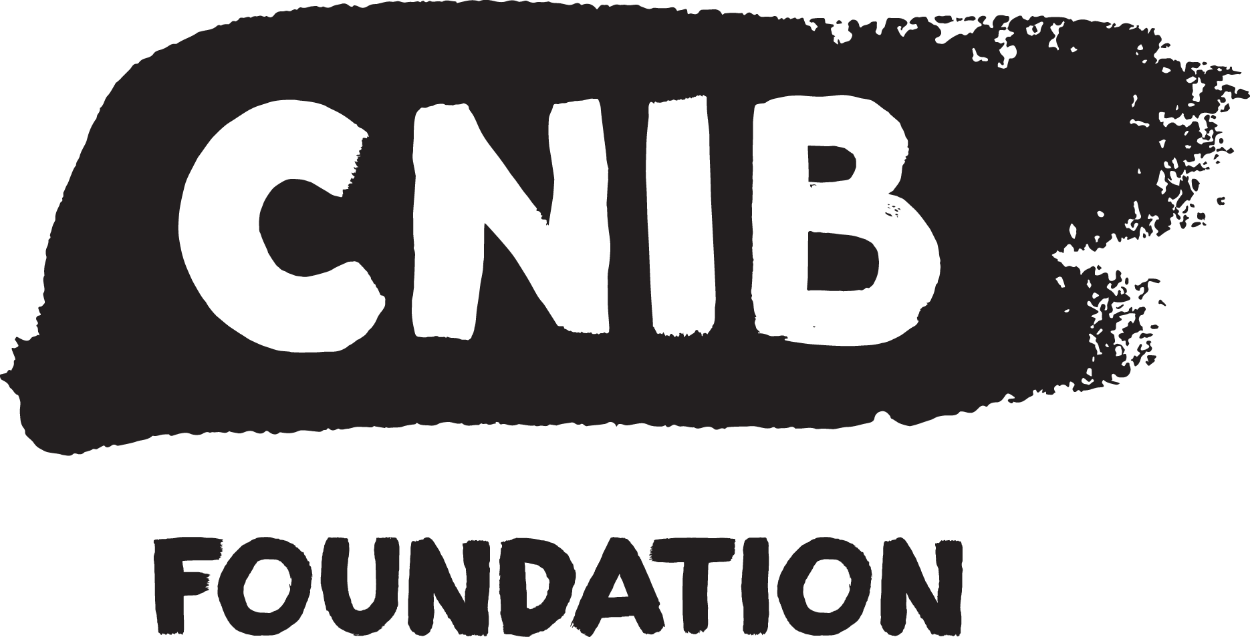

Building Bridges To Belonging

CNIB 2023-2028 Accessibility Strategy

Contents

Vision 1
Purpose 1
Guiding Principles 1
Key Themes and Priorities 1
Culture 1
Learning 1
People 1
Technology & Tools 1
Roles and Responsibilities 1
Measurement 1

Vision
CNIB will live and lead by example in accessibility and creating and maintaining an inclusive workplace. This means not only meeting accessibility standards and principles but also living and striving to exceed expectations and set new boundaries.

We will do this through our commitment to excellence in IDEA (Inclusion, Diversity, Equity, and Accessibility) principles and our focus on serving our employees and volunteers. IDEA principles are the standards in how we exercise creative thought, empathy, and common sense to design a workplace that empowers every one of us and provides the resources to fulfill our potential.

Purpose
This Accessibility Strategy outlines how we will lay the building blocks to move the needle on accessibility and inclusion. It establishes the accessibility and inclusion direction for the organization and details how we will contribute to our ambitions to become a model in the area of accessibility in the workplace.

CNIB is committed to creating spaces of belonging for our people – our clients, volunteers, donors, and colleagues. Our people come to us from all walks of life, and we take pride in being a community made up of a myriad of lived experiences and intersecting social identities.
To deliver programs and advocacy that empower Canadians impacted by blindness, we will remain steadfast in working to understand and support the diverse experiences and needs of our clients, volunteers, donors, and colleagues. As part of our journey to becoming a truly inclusive and accessible workplace, we know that we can always do better when it comes to honouring and empowering our people. This includes recognizing the ways that ableism, racism, colonialism, sexism, queerphobia, and other forms of systemic discrimination exist within our spaces. We commit to identifying, removing and preventing barriers that exclude anyone from being meaningfully engaged in our world.
We share accountability for creating a more equitable, inclusive and accessible CNIB that insists on inclusion and belonging, and celebrates self-expression. We will ensure adequate time and resources to promote IDEA in our work and work environments so that every individual is supported for success in their role. True inclusion is a responsibility to be upheld by every member of our team, and we’re proud to take on the hard work of continuous improvement.
- We will foster an inclusive workplace that promotes dignity and integration, and respects diverse needs across all levels and business units.
- Accessibility, usability, and inclusion will be driving considerations in our procurement of goods, services, and business solutions. Where available solutions do not meet our needs and standards, we will advocate to our vendors and service providers to improve their offerings.
- Managers and leadership will be accountable for upholding accessibility and inclusion standards and inclusive workplace principles in their decision-making practices.
- Managers and leadership will be held accountable in creating accessible, inclusive service delivery platforms.
- We will provide training opportunities and tools so that IDEA and belonging are embedded in our culture and practices.
- We will work together to identify and remove current barriers to accessibility and inclusion and prevent the emergence of new ones.
- The Chief Accessibility Officer and IDEA team will give support and guidance, and ensure adherence to the highest principles in accessibility and inclusion.
Delivering on our commitment effectively requires leadership, collaboration, and a steadfast focus on the goal of an equitable future for all. Together, we will make that vision a reality.

Guiding Principles
The Accessibility Strategy is guided by the following principles:
- Accessibility is for everyone
Accessibility is about creating and designing environments, workplaces, and communities that enable every one of us to participate fully without barriers.
- Leading with lived experiences
Lived experience is at the heart of the Accessibility Strategy, bringing a perspective to accessibility that recognizes that individuals’ lived experiences are shaped by their intersecting identities.
- Accessibility is a core part of who we are
Accessibility is a way of thinking, doing, living, and is fundamental to our ability to engage and interact with our employees, volunteers, and program participants.
- Accessibility is a collective responsibility
Everyone understands the role they play in identifying, preventing and removing barriers, and how they can help support the organization by playing their part in accessibility.

Key Themes and Priorities
We consulted with staff across the organization to gather feedback as a source of ideas and to draw upon input about overall directions of accessibility. Staff shared their sentiments and feelings on a wide range of topics; we have narrowed down a number of key focus areas based on themes that came up again and again throughout our consultations.

Accessibility initiatives will fall into the following focus areas: Culture, Learning, People, Technology and Tools.

Culture
We will foster a culture of inclusion that embraces diverse abilities and lived experience.

Key tactics that fall under this pillar include:

Tactic 1: Commitment to accessibility and inclusion.
OBJECTIVE: Review and renew accessibility and inclusion commitment for the organization to guide direction of goals and priorities.

TACTIC 2: Deepen IDEA knowledge
OBJECTIVE: Engaging opportunities that facilitate conversations and interactions to think, talk, and deepen knowledge to help employees better understand intersectionality, diverse lived experience, and how their actions and behaviours can support an accessible and inclusive workplace.

TACTIC 3: Safe and inclusive workplace
OBJECTIVE: Ensure that equity process and policies are inclusive and protect all employees from discrimination, harassment, and violence no matter their diverse lived experience to create a safe and inclusive workplace environment for everyone.

TACTIC 4: Refresh Accessibility and Inclusion Champions Network (AICN)
OBJECTIVE: To use the AICN to create a platform to mobilize employees and a renewed roadmap of activities that drive accessibility and culture.

TACTIC 5: Develop employee resource group (ERG) framework
OBJECTIVE: To use employee-led platforms to mobilize employees to connect and provide peers with safe spaces, enhance employee well-being, and foster a more accessible and inclusive workplace.

Learning
We will create an interactive and engaging learning environment designed to support everyone in deepening their understanding, empathy, compassion, and to foster an inclusive culture.

Key tactics that fall under this pillar include:

TACTIC 6: Build accessibility competencies
OBJECTIVE: To increase the availability and range of organization-wide accessibility and inclusion training and development to ensure everyone at all levels of the organization are equipped with accessibility competencies and resources and tools to apply accessibility competencies in their day-to-day roles. (e.g. accessible documents, accessible meetings and presentations, communications in the workplace, digital accessibility, etc.)

Tactic 7: Impact training
Objective: To develop and launch organization-wide disability sensitivity training for all staff to help employees better understand different perspectives, experiences, and abilities.

Tactic 8: Intersectional IDEA knowledge
Objective: Promote learning opportunities to build intersectional IDEA knowledge and confidence to in speaking about IDEA efforts, sharing IDEA messaging, and demonstrate a visible commitment to practicing IDEA principles.

Tactic 9: Leadership commitment
OBJECTIVE: Ensure that leadership in the organization build the capabilities to practice IDEA principles and demonstrate a visible commitment to inclusion.

TACTIC 10: Review and refresh volunteer competencies framework.
OBJECTIVE: Ensure volunteer orientation, onboarding, and training effectively build and strengthen accessibility and inclusion competencies to support organization IDEA principles.

TACTIC 11: Develop training framework to build competencies among national Board and committee volunteers
OBJECTIVE: Ensure board and committee volunteers have competencies and capabilities to apply relevant skills to their work with the organization. (e.g. integrity and respect, accessibility and inclusion, diversity and equity, lived experience,, etc.)

People
We will foster and maintain an inclusive workplace environment designed to provide everyone with a first-rate experience, that considers individual preference and ability, from the moment they join the organization.

Key tactics under this pillar include:

TACTIC 12: Review/enhance recruitment process for inclusion
OBJECTIVE: To implement best practice hiring standards in Talent Attraction Strategies with the goal to increase diverse representation.

Tactic 13: Review employment lifecycle for inclusion
Objective: Examine policies against ASC draft employment standards to create a positive workplace environment where employees can thrive.

TACTIC 14: Train managers on inclusive and accessible recruitment and selection processes and practices
OBJECTIVE: Level the playing field for all candidates to remove recruitment bias and discrimination with the goal to recognize diversity and a wide range of abilities.

TACTIC 15: Refresh planning and implementation process during employee onboarding for regular reviews of workplace accommodations
OBJECTIVE: Promote practices that retain agency and facilitate two-way dialogue, shared decision making, shifting the focus of the conversation to be more about “enablers and supports that will help individuals be more successful,” create an opportunity to review employee supports,, and address shifts in an individual’s needs.

TACTIC 16: Flexible workplaces
OBJECTIVE: Create a workplace to reflect the diverse needs of employees. (e.g. flexible arrangements including job customization, scheduling, work styles, transportation needs, medical needs, etc.)

TACTIC 17: Expand professional development programs to increase diverse representation in all levels of the organization.
OBJECTIVE: To build accessible and inclusive Talent Development programs, Sponsorship programs, and Succession planning that invests in employees and prioritizes the development of a diverse and inclusive talent pipeline.

Tactic 18: Establish an accessible and inclusive volunteer onboarding process
Objective: Review the volunteer onboarding process, including materials, forms, documentation, and processes, to ensure processes considers individual’s needs and embraces diverse perspectives.

Tactic 19: Integrate accessibility and inclusion training into volunteer onboarding and socialization processes.
Objective: Ensure volunteers effectively apply accessibility and inclusion principles in the delivery of programs and services to create meaningful experiences that benefit everyone.

Technology & Tools
We commit to ensuring everyone has access to the technology and tools they require to be successful, in an accessible way.

Key tactics that fall under this pillar include:

Procurement
TACTIC 20: Review and refresh procurement policies and practices
OBJECTIVE: Embed accessible procurement principles to ensure accessibility is considered at all stages of the procurement process and collaborate with vendors to identify and remove known issues to prevent future accessibility issues with the goal to improve accessibility in instances where current tools are not fully accessible.

TACTIC 21: Systems accessibility working group
OBJECTIVE: Establish and maintain a group of representatives from across the organization who will be responsible for providing high level guidance on the accessibility and usability of all business systems to ensure accessibility is considered at all stages of the process.

Information
TACTIC 22: Accessible communications
OBJECTIVE: Refresh accessible communications policy to ensure equal access to information for everyone with the goal to improve overall communications effectiveness.

Tactic 23: Develop training resources and implement training on accessible communications
Objective: To equip staff with the knowledge, skills, and tools they need to create and deliver content that is accessible to a diverse audience.

Tactic 24: Information access
Objective: Rethink approach to the design of data visualization and the way complex information is presented with the goal to ensure that information is accessible, comprehensible, and inclusive for everyone.

Physical space and safety
Tactic 25: Conduct an evaluation to identify and address accessibility barriers in owned and leased offices
Objective: To use the Local Office Accessibility Framework to evaluate office accessibility with the goal to identify barriers, take necessary actions to remove barriers, and guide the implementation of improvements to ensure inclusion for everyone.

Tactic 26: Create accessible and user-friendly maps of locally and regionally owned offices with accessibility reference information for each property
Objective: Explore leading cartographic practices to enhance the visualization of maps for owned properties.

Tactic 27: Integrate emergency response features with indoor navigation solutions
Objective: Investigate indoor navigation solutions that incorporate emergency response features to enhance emergency response capabilities and preparedness, and improve efficient navigation and timely assistance in critical situations.

Tactic 28: Physical navigation and wayfinding in the workplace
Objective: Review and refresh the use of beacon navigation technology at owned properties to improve navigation.

Tactic 29: Expend the use of beacon technology in leased properties
Objective: Collaborate with landlords to explore the implementation of beacons in leased properties with office locations.

Tactic 30: Variable lighting
Objective: Review and refresh the use of variable lighting within our owned properties to enhance lighting requirements.

TACTIC 31: Develop accessible emergency safety plans
Objective: Enhance safety and emergency processes and policies for accessibility and inclusion to ensure that everyone has equal access to safe and effective emergency procedures and responses.

Roles and Responsibilities
Accessibility is our collective responsibility. The entire organization – every single department, each individual employee – plays a vital role in accessibility. Some departments are more overtly involved than others, but every aspect of the organization is represented in the Accessibility Strategy.

The Executive Leadership Team (ELT) and Operations Management Team (OMT) set the tone for accessibility by establishing the direction we are all working towards and what we are trying to achieve.

The IDEA Team takes on the role of ensuring the Accessibility Strategy establishes frameworks to ensure initiatives are supporting accessibility across the organization. Specifically, the IDEA Team puts in place departmental support to ensure the rest of the organization has the accessibility and inclusion support they need.

From there, the IDEA Team will collaborate with other departments and teams across the organization to develop plans that include: mapping activities that support accessibility, aligning priorities and goals, coordinating workflows, and focus on implementing accessibility initiatives.

Measurement
For every initiative or action we have a measurement attached to ensure we can track our progress and inform future decisions as they relate to accessibility. (Appendix A)

In addition to tracking against all metrics across each project lifecycle, this Accessibility Strategy will ultimately be measured by the overall perception of where we are as an accessible and inclusive workplace. Perceptions will be measured by the Accessibility and Inclusion Maturity Model (AIMM) based on a score of 1 to 5, where 5 is the highest score. As an organization, we currently score between a score of 2 and 2.5 with a baseline established in 2022. Although this Accessibility Strategy will only span five years, are hope is that it will lay the ground work required to build on for years to come. The goal is to create an Accessibility Strategy that drives the needle and moves the organization along the accessibility journey, reaching an AIMM score between 3 and 3.5 by 2028.

